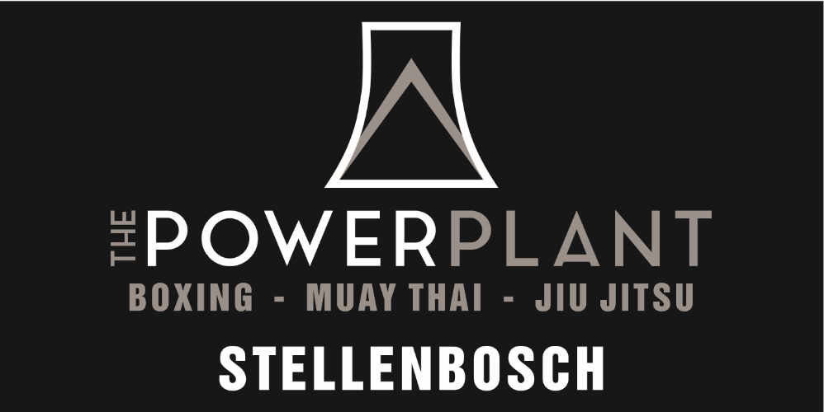
The Powerplant Fitness Centre (Pty) Limited
Unit 5, Devon Park, 10 Santhagen Road, Stellenbosch
2021 Training Schedule
 | Monday | Tuesday | Wednesday | Thursday | Friday | Saturday
06:00 – 07:00 | Muay Thai Fit |  | Muay Thai Fit |  | Muay Thai Fit
07:00 – 09:00 | Privates | Privates | Privates | Privates | Privates | Privates
09:00 – 10:00 |  | Box Fit Ladies |  | Box Fit Ladies |  | Muay Thai /  Kickboxing
10:00 – 16:00 | Privates | Privates | Privates | Privates | Privates | Privates
16:30 –17:20 | Little Champs  Kickboxing | Bully Proof Kids Jiu-Jitsu | Little Champs  Kickboxing | Bully Proof Kids Jiu-Jitsu
17:00 –18:00 |  |  |  |  | Grappling / Sparring Open Mat
17:30 –18:30 | Muay Thai / Kickboxing | Boxing | Muay Thai /  Kickboxing | Boxing
18:00 –19:30 | Beginners Jiu Jitsu | Jiu-Jitsu |  | Jiu-Jitsu
18:30 –19:30 | Muay Thai /  Kickboxing |  | Muay Thai /  Kickboxing

***We have divided our classes into two main categories: “Stand Up” and “Ground” classes. Stand up classes consist of boxing and muay thai kickboxing classes. Ground classes consist of Brazilian Jiu Jitsu and No-Gi Grappling. All classes implement their own unique styles of fitness and conditioning drills. ***Personal one-on-one training (Privates) are available to all members and these are arranged with our coaches directly. We also cater for a combination of group and private training to suit every individual’s needs.

- FEES, MEMBERSHIP AND REGISTRATION
  - A once-off registration fee of R 200.00 is payable to The Powerplant upon signature and presentation of this membership contract.
  - All contracts are for a fixed period of 12 months payable in advance or by debit-order only. Regrettably, we do not accept any cash payments and urge our members to make use of EFT when making any payment to The Powerplant.
  - We offer the following membership packages and pricing structures:
    - Full Membership @ R 700.00 per month
    - Student’s and Essential services Membership @ R 600.00 per month
    - Kids’ Membership age 5 -13 @ R450.00 per month
    - Private rates are calculated individually for each client, depending on their specific needs.
  - We offer a 25% discount to members who sign up for a 12-month membership and who pay the full amount in advance.
- TERMS AND CONDITIONS OF MEMBERSHIP
  - We DO NOT cater for memberships to be suspended and/or postponed for specified periods due to a reason not associated with injury. We acknowledge that students often live out of town and will travel home for holidays, making it impossible for them to train over these periods. In the event that a member wishes to stop payment for any such reason, they are obligated to inform The Powerplant no fewer than 30-business-days prior to their leaving, so that the debit order instruction can be effectively cancelled.
  - Please be advised that in all situations The Powerplant requires a minimum of 30-business-days notification of a member’s intention to end their contract so that the debit-order instruction can be cancelled. Failure to provide us with the requisite notice will result in the payment being accepted by The Powerplant and in such an event, no refund will be issued.
  - Payment of all amounts must be made prior to any member attending classes. The policy of “no pay no train” will be strictly enforced at the gym and members who fail to make monthly payments, will be asked to leave the session by the Coach.
  - Missed classes cannot be “saved” and/or caught up and/or carried over into another month. A missed class is a missed class and it is the prerogative of the member to ensure that they display satisfactory attendance. Continual training is a requirement to excel in any of the disciplines offered by The Powerplant and members are urged to ensure that they attend classes regularly in order to obtain the best training possible.
  - Each class has its own dedicated WhatsApp Group so that coaches can make arrangements with members regarding future sessions. Please request that we add you to the relevant group once you have joined The Powerplant family.
  - In special circumstances, The Powerplant is prepared to consider deferring a membership for a maximum period of 1 (ONE) month only. Enforcement of such a deferral remains the sole election of The Powerplant and will only be considered where a member provides The Powerplant with proper notice of their required deferral, along with a valid reason due to a recognised injury sustained during one of the training sessions.
  - Should an active member enter any Gi/No-Gi grappling tournament, MMA, submission wrestling, K1, boxing or kickboxing tournament and/or other competition, you are required to compete under the banner of The Powerplant or Nakeang Muay Thai Academy, depending on the particular tournament.
  - Right of admission remains reserved.
  - Members have the right to lay any complaint in writing directly to Management.
  - The Powerplant reserves the right to cancel a membership with immediate effect where circumstances justify such action.
  - Cancellation by a member must be made no fewer than 30 business-days prior to the intended date that the member will cease to train and notice of cancellation must be delivered in writing to Management.
- HYGIENE
  - Please stay hygienic and considerate towards you fellow members. The disciplines offered by The Powerplant are of such a nature that there will be close contact between members. All members are obliged to bring a sweat towel to classes and to ensure that all equipment is wiped down after use. Clothes, kit, gi’s and other items worm by members are to be kept clean and hygienic. All members should be considerate to one another as no one wants to have close contact with a person whose kit is not properly washed. Our Coaches on a case-by-case basis will reproach members who do not abide by this principle of cleanliness.
  - Shower and toilet facilities are available to all members on the premises. Whilst maintenance of these facilities remains the sole prerogative of The Powerplant, we have an established culture where members clean up after themselves when they have finished with a particular session. We value a safe, clean and hygienic environment, which is conducive to discipline and self-development.
  - Members must practise proper hygiene and cleanliness at all times when visiting The Powerplant. To this end, members must wear clean and appropriate clothing, maintain short nails and ensure that long hair is properly tied back during training.
  - No sharp objects or shoes are allowed onto our mats and members will be reprimanded for failing to heed to this rule. Jiu Jitsu requires that members must work on the mats and no one wants to be rolling around on a mat that has been tarnished by dirty shoes.
  - Respect your training partners, our Coaches, other members and the dojo. Bad egos, poor attitudes and losing your temper during training sessions is not tolerated. Coaches and/or Management reserve the right to ask a member to leave where they display any such untoward behaviour.
  - In the event that a member feels aggrieved by the lack of hygiene in relation to any of The Powerplant’s facilities and/or another member, members must address their concerns with a Coach or Manager as soon as possible, so that the situation may be resolved.
  - Storage shelves are provided for members for any bags, shoes, or other personal items brought into the gym. Please be considerate towards you fellow members and refrain from using these shelves as permanent storage, or a place to leave rubbish.
  - The Powerplant has a fridge, which may be used by members to purchase a Bos Ice Tea during training. We work on a “trust bar” policy and members must pay for any drinks taken from the fridge during their visit to the premises by placing the cash into the drop safe that is located on the premises. Whilst we cannot police over our members, theft will not be tolerated and should a member be caught trying to steal from the Powerplant, they will be prosecuted in accordance with the prevailing law.

- MEMBERS’ PERSONAL ITEMS
  - Any items left in the gym for a period of 5 (FIVE) business-days or more will be donated to charity without any further notice to members. The Powerplant cannot accept responsibility to ensure that such items are kept safe.
  - The risk of loss and/or damage to any personal items brought onto the premises by a member lies exclusively on the member. The Powerplant (including Managers and Coaches) cannot accept responsibility/liability for any loss or damage to personal belongings whilst they are stored on our premises during training. The Powerplant might assist a member in instance where such harm/loss is caused as a direct result of negligence/intention on the part of a Manager or Coach of The Powerplant.
  - Members are obliged to bring any such loss/harm to a Manager and/or Coach’s attention immediately and each situation will be considered on a case-by-case basis in accordance with the specific circumstances of the loss/harm where a member seeks reimbursement for any such loss/harm.
- INJURY AND WAIVER OF LIABILITY
  - The nature of the training offered by The Powerplant is such that injury is part-and-parcel of progressing in the particular discipline chosen by a member. Kickboxing and Jiu Jitsu are recognised forms of martial arts, which require members to spar and/or grapple with one another on a regular basis. Due to lack of experience, the possibility of a member suffering an injury whilst training does indeed exist, no matter what steps are taken by The Powerplant and its Coaches. To this end, The Powerplant cannot accept any responsibility and/or liability for any injury suffered whilst training at our facility. Whilst our Coaches will endeavour to ensure the safety of all members, we cannot provide an absolute guarantee that all members will remain injury free. It is an inherent risk in the chosen activity and members acknowledge that they have consented to the possibility of suffering such harm when participating in any particular class.
  - The Powerplant, its owners, employees, representatives and/or agents shall not accept liability for any loss, damage or injury of any nature, or death, whether arising from negligence or otherwise which is suffered by any person who enters and/or trains on the premises.
- CONFIDENTIALITY
  - Training methods and intellectual property obtained at The Powerplant are to be kept confidential and are not to be taught to anyone who is not a member.

WRITTEN AUTHORITY AND DEBIT MANDATE

I/We authorise IMAGIN8, Insure Group Managers Ltd, or their authorized Third Party (Herein after referred to as Epic) to draw against my/our bank account the contracted value in terms of an authority/mandate from The Powerplant Fitness Centre to collect and manage monies in respect of martial arts training undertaken by students (customers) at The Powerplant Fitness Centre (“Agreement”) for which I/we extend this authority to collect by debit order.

I/We further authorise Epic to increase or reduce such amounts due from time to time to reflect any change to the Agreement, including changes in the base agreement cost, additional services, products, transactional costs as communicated to Epic by The Powerplant Fitness Centre.

I/We understand that the withdrawals hereby authorised will be processed through a computerised system provided by the South African Banks and I/we understand that details of each withdrawal will be printed on the bank statement, with the reference prefix “The Powerplant Fitness Centre”.

This authority remains in force until cancelled in writing by me/us.

Name of Insured ________________________________________
Account Holder name ________________________________________
(If different to Insured)
Address of Account Holder _______________________________________
________________________________________
Amount ________________________________________
Date ________________________________________
Bank name ________________________________________
Branch name and code ________________________________________
Town/City ________________________________________
Type of account ________________________________________
Account number

The individual debit and/or payment instructions so authorised to be issued must be issued and delivered as follows: (delete that which is not applicable)
MONTHLY

In the event that the payment day falls on a Sunday, or recognised South African public holiday, the debit day will automatically be the preceding ordinary business day.
I further authorise Epic to deposit directly into the above account any amount that may be due to me/us in respect of any refund amounts.
We shall not be entitled to any refund of amounts that Epic has withdrawn while this authority was in force, if such amounts were legally due.

ACCOUNT HOLDER MANDATE
I/We acknowledge that all debit instructions issued by Epic shall be treated by my/our above-mentioned bank as if the instructions had been issued by me/us personally.

Signed at ____________________ on this ___ day of _______________________________

___________________________________ __________________________
(Signature as used for operating on the account) Name
MEMBERSHIP AND INDEMNITY
Name: _____________________________________________________
Surname: _____________________________________________________
Identity number: _____________________________________________________
Physical Address: ______________________________________________________
___________________________ Code: _____________________
Postal Address: ______________________________________________________
____________________________Code: ____________________
Cell: _____________________ Home: _________________________
E-Mail: _____________________________________________________
ICE contact: _____________________________________________________
Membership option (please tick next to your choice):
Full: Student: Kids:

Period of Membership: ________________________________________________
Commencement date: ________________________________________________
EFT Details:
ACCOUNT HOLDER: THE POWERPLANT
BANK: FIRST NATIONAL BANK
ACCOUNT NUMBER: 624 821 744 73
ACCOUNT TYPE: BUSINESS
BRANCH CODE: 250 655
REFERENCE: YOUR NAME AND REASON FOR PAYMENT

MEDICAL QUESTIONAIRE
***The Powerplant cannot and shall not be held liable for any injuries or losses which might be suffered by a member due to a re-occurring and/or acute illness or injury not disclosed herein-below. It is the responsibility of members to ensure that they are healthy and fit enough to take part in the classes effectively, as well as to refrain from training when they are suffering from any contagious and/or debilitating illness during the tenure of their membership. We are not your mother and we do not expect to have to be your parents as well.
Please list any and all illnesses, injuries and other health-related problems which you have or continue to suffer from in the last 12 (Twelve) months. Please indicate whether these have been resolved or are re-occurring and provide us with written consent from your doctor that you may train, where the same is required due to the nature of the illness and/or injury:
_________________________________________________________________________
_________________________________________________________________________
_________________________________________________________________________
_________________________________________________________________________
_________________________________________________________________________
Doctor’s contact details: ______________________________________________________
Doctor’s address: ______________________________________________________

MISCELLANEOUS
Where did you hear about The Powerplant? ____________________________________
What is you martial arts background? ____________________________________
_________________________________________________________________________
_________________________________________________________________________

ACCEPTANCE OF TERMS AND CONDITIONS OF MEMBERSHIP
I, the undersigned, do hereby acknowledge and agree that the training sessions and facilities provided by The Powerplant have been specifically designed to ensure my safety at all times and to encourage the best possible results from regular training. I herewith undertake to train safely and to endeavour to work alongside The Powerplant and its representatives to ensure and promote my own personal safety, as well as the safety of fellow members.
I confirm that I have read and understood the terms and conditions contained in this membership contract. Where I have not understood a particular term or condition, I confirm that I have brought this to the attention of a representative of The Powerplant who then explained it to me to my own satisfaction ensuring that I fully understand and appreciate the nature and effect of such term. Where I required the membership contract to be translated into an alternative language (as contemplated in the Consumer Protection Act, Act 68 of 2008) I have requested this and confirm that I have been provided with a translated version ensuring that I fully understood and appreciated all terms and conditions prior to undersigning this membership contract. I confirm that I have familiarised myself with the terms and conditions contained herein and hereby agree to remain bound by them.
I confirm that I have consulted with a physician, doctor, or medical professional prior to commencing my training at The Powerplant, and that such medical professional has given me the all-clear to proceed with my chosen martial art.
This agreement constitutes the entire agreement between the parties and no indulgence, relaxation, waiver or variation from any term or condition contained herein shall of any force and effect between the parties unless such variation or addition has been reduced to writing, undersigned by all parties and annexed to this membership contract.
THUS done and dated on this the day of 2020.
Member: _____________ Parent/Guardian (member under 18 years): ______________

